| **Ex no : 1** | **Implementation of Multi-layer network for MNIST Dataset.** |
| --- | --- |
| **Date :** |

**AIM**

To study the difference between single layer and multi-layer network and implement multi-layer network for MNIST dataset

**BASIC THEORY of ANN.**

* Input value or One input layer: The input layer of the perceptron is made of artificial input neurons and takes the initial data into the system for further processing.
* Weights and Bias:
* Weight: It represents the dimension or strength of the connection between units. If the weight to node 1 to node 2 has a higher quantity, then neuron 1 has a more considerable influence on the neuron.
* Bias: It is the same as the intercept added in a linear equation. It is an additional parameter which task is to modify the output along with the weighted sum of the input to the other neuron.
* Net sum: It calculates the total sum.
* Activation Function: A neuron can be activated or not, is determined by an activation function. The activation function calculates a weighted sum and further adding bias with it to give the result.

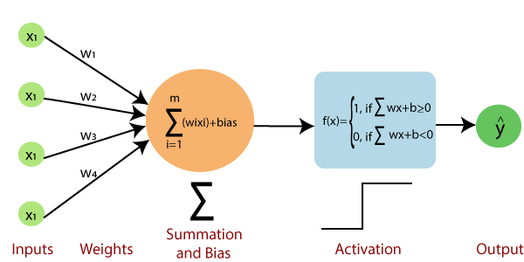

**PROCEDURE AND CODE**

1. Import the following libraries
   1. Tensorflow
   2. Form tensorflow import keras
   3. From keras import sequential model
   4. From keras import dense and flattern layers

**Code**

import tensorflow

from tensorflow import keras

from tensorflow.keras import Sequential

from tensorflow.keras.layers import Dense,Flatten

1. Download MNIST dataset directly from keras example datasets and split train and test data.

**Code**

(X_train,y_train),(X_test,y_test) = keras.datasets.mnist.load_data()

1. View the shape.

Code

X_test.shape

X_train.shape

y_train.shape

y_test.shape

1. View the class labels in y_train

**Code**

y_train

1. Import matplotlib and view any sample in x_train and verify the value in y_train matches the figure by manually.

**Code**

import matplotlib.pyplot as plt

plt.imshow(X_train[2])

1. Divide x_train and y_train by 255

Code

X_train = X_train/255

X_test = X_test/255

1. View the data of first image in x_train

**Code**

X_train[0]

1. Create sequential model and add flatten and dense layers

**Code**

model = Sequential()

model.add(Flatten(input_shape=(28,28)))

model.add(Dense(128,activation='relu'))

model.add(Dense(32,activation='relu'))

model.add(Dense(10,activation='softmax'))

1. **View model summary**

**Code**

model.summary()

1. **Compile and fit the model**

**Code**

model.compile(loss='sparse_categorical_crossentropy',optimizer='Adam',metrics=['accuracy'])

history = model.fit(X_train,y_train,epochs=25,validation_split=0.2)

1. **Create y_pred variable**

**Code**

y_prob = model.predict(X_test)

y_pred = y_prob.argmax(axis=1)

1. **Import metrics from sklearn and view the accuracy score**

**Code**

from sklearn.metrics import accuracy_score

accuracy_score(y_test,y_pred)

1. **Plot the actual and validation losses, accuracies**

**Code**

plt.plot(history.history['loss'])

plt.plot(history.history['val_loss'])

plt.plot(history.history['accuracy'])

plt.plot(history.history['val_accuracy'])

1. **Test with any random input**

**Code**

plt.imshow(X_test[1])

model.predict(X_test[1].reshape(1,28,28)).argmax(axis=1)

**OUTPUT**

Loss during training and validation

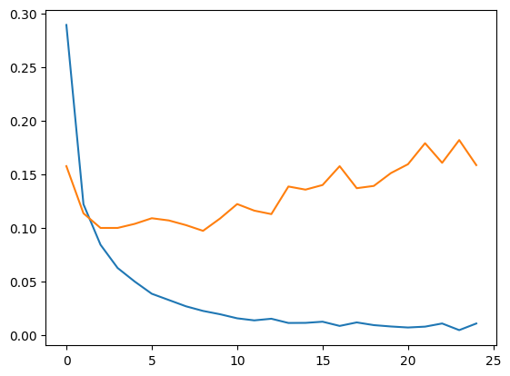

Accuracy during training and validation

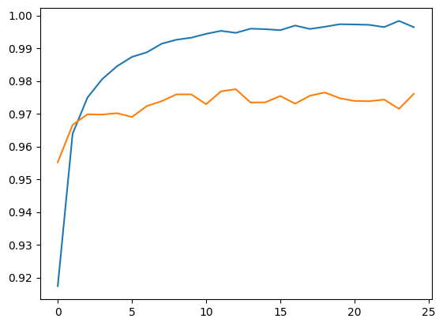

**RESULT**

Thus multi-layer neural network with a input layer (flatten layer), three hidden layers(dense) ,out of which last one is output layer has designed and implemented for MNIST dataset successfully.